# Simulation screenshots

**Circuit Diagram of OPAMP**

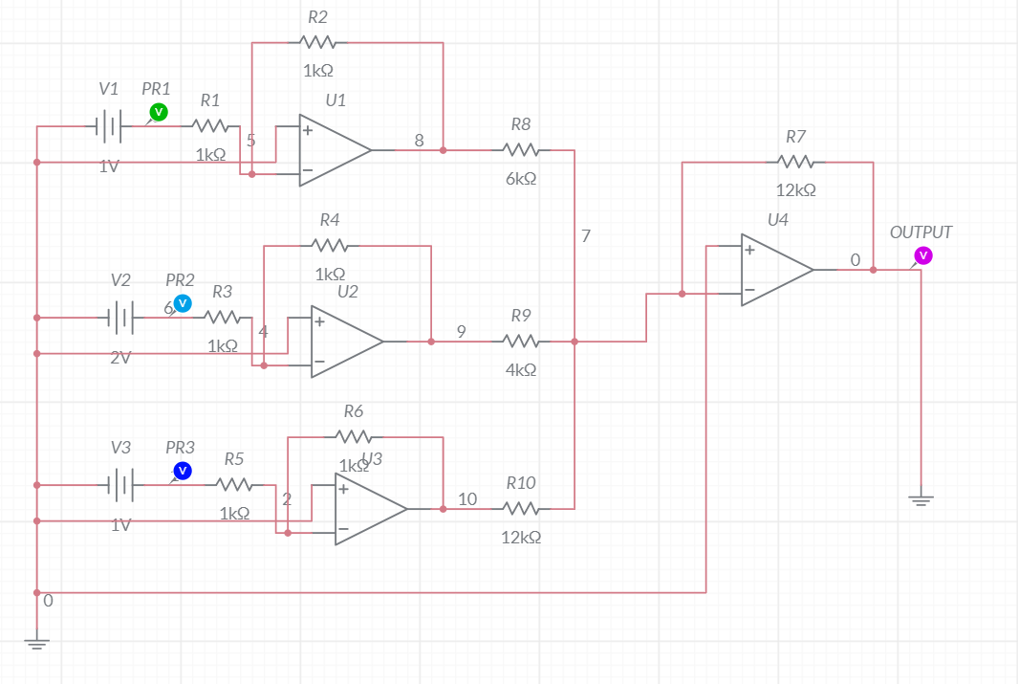

**Grapher Image**

